CS 340 README Template

Use this template to complete your README file. When completing the template, keep the headings as they are so that your document has a clear organization. Remove the italicized prompt text after you have completed each section for a polished final document.

About the Project/Project Title
This is a project designed for Grazioso Salvare a Fictional company that provides an application for the selection of animals eligible for animal rescue service training at Austin Animal Center. The application is designed to provide an efficient way for the company to sort and select breeds from a mongoDB. It does this by using the pymongo libraries and basic sorting logic.

I highly recommend the removal of Hard coded passwords and account information if the decision is made to implement this program in a Real World Environment.

Motivation
This project works as a skill example for what I am able to do with MongoDB and python. Furthermore, for the company this streamlines the process of selecting animals and provides a framework for an expedited research process.
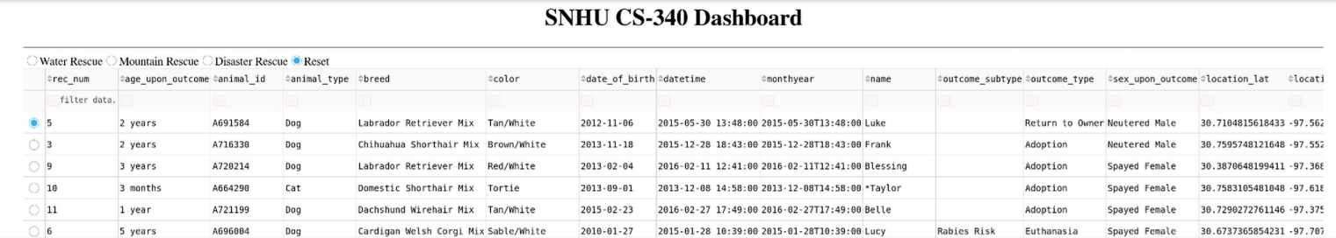
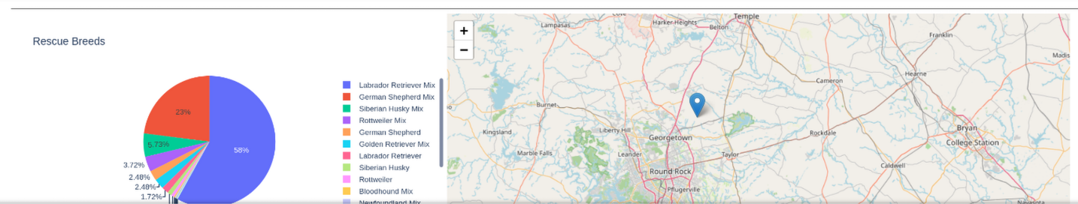
This shows the application in action. As you can see this application formats the data in an easy to understand format.

Getting Started
The set up for this application is a duplication of the Crud module itself. Witht he exception of updating the password information in the ProjectTwoDashboard.Ipynb file. As such the following will walk you through the process of setting up the mongo system.

The following instructions assume you have preinstalled MongoDB on your pc or that the network your running this software on has local access to the MongoDB server if you have no follow the instructions on the official MongoDB website here before continuing with the set-up.

Setting up admin account:
To preform the desired operations the application needs read write privileges which can be granted via creating a user account in the database . this must be done within the mongo database prior to the usage of this software. You can do this in the database using the db.createUser function.
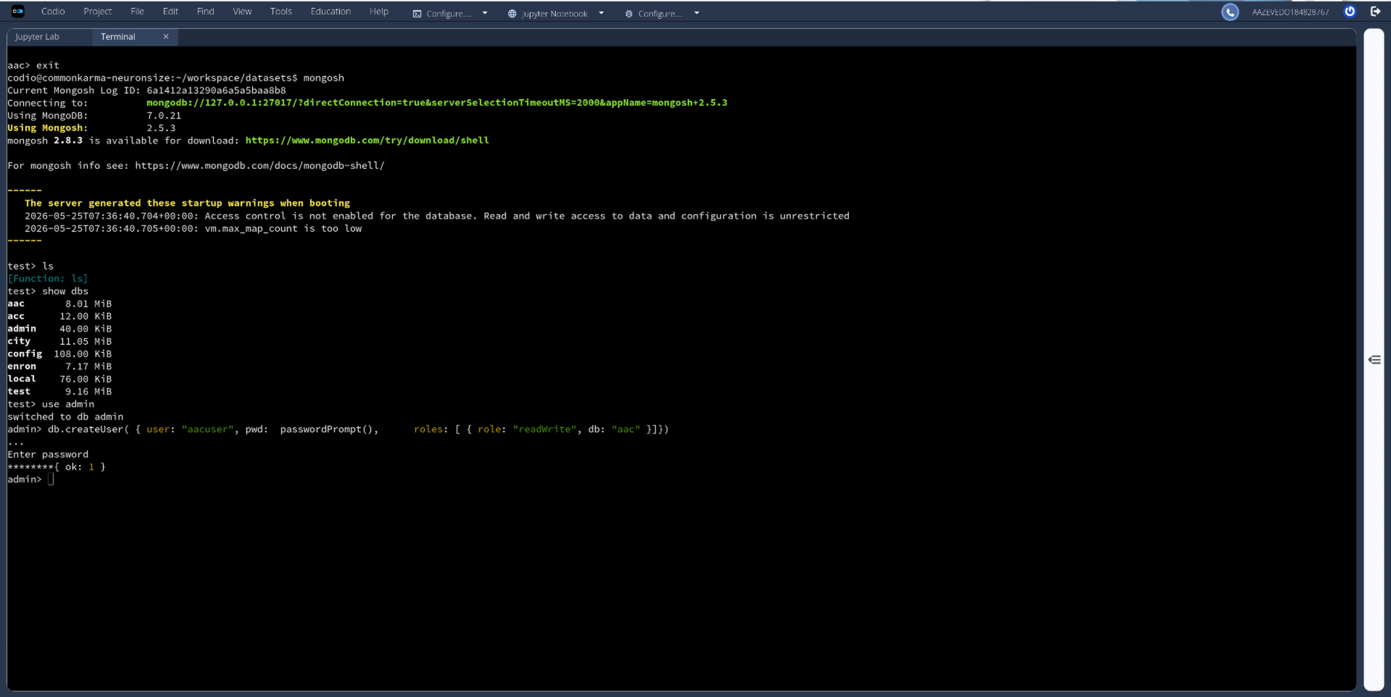

The next step is to implement said info into the softwares self function.

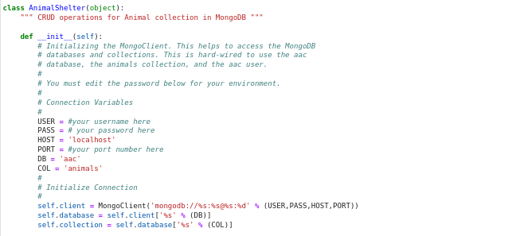
This should be the basic needed to get the file running.

Installation
For this project you will need the following requirements
- pymongo: https://pypi.org/project/pymongo/
  - Used for the operations and command access.
- bson.objects: https://www.nuget.org/packages/mongodb.bson/
  - This is the primary communication of the mongo database. Simplified this is a json styles used by mongoBD.
- pprint : https://docs.python.org/3/library/pprint.html
  - Pretty printer is a formatted print function.
For Project 2 file
- Dash/plotly :https://dash.plotly.com/
  - This is the plotting software
- Numpy :https://numpy.org/
  - This is a statistics software for python
- Pandas: https://pandas.pydata.org/
  - This is a statistics software for python
- Matplotlib:https://matplotlib.org/
  - This is a statistics plotting software for python
Everything else should be preinstalled with python.

Usage
Use this space to show useful examples of how your project works and how it can be used. Be sure to include examples of your code, tests, and screenshots.

Code Example
The following code snippet shows the back end logic behind how the buttons in the application function. Each button is linked to its own logic which dictates what query each button activates.
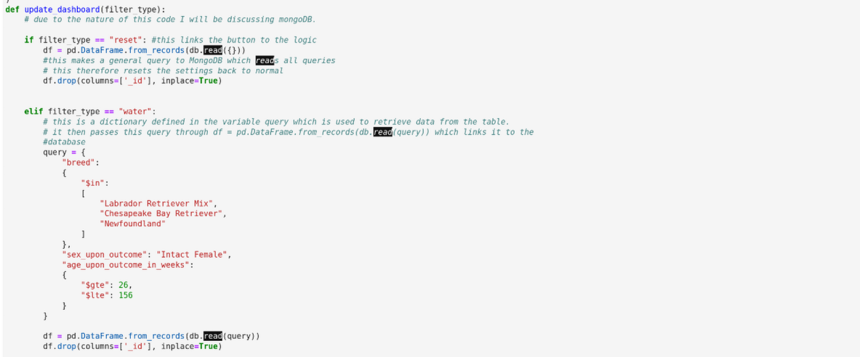
The following is the result: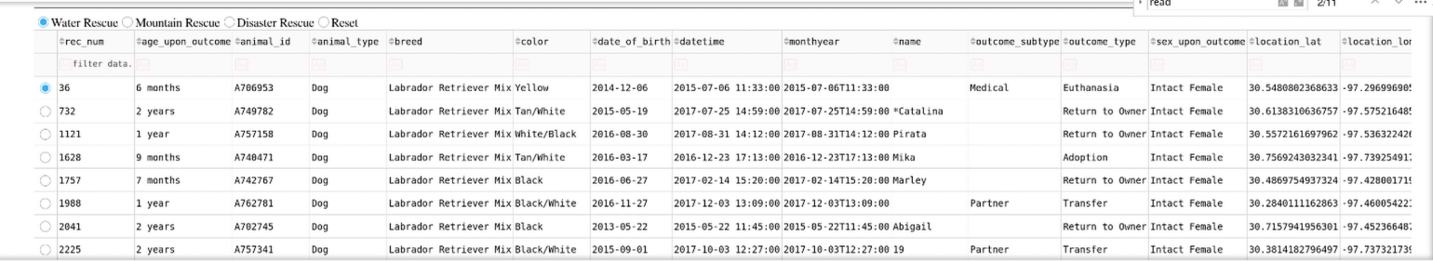

Screenshots
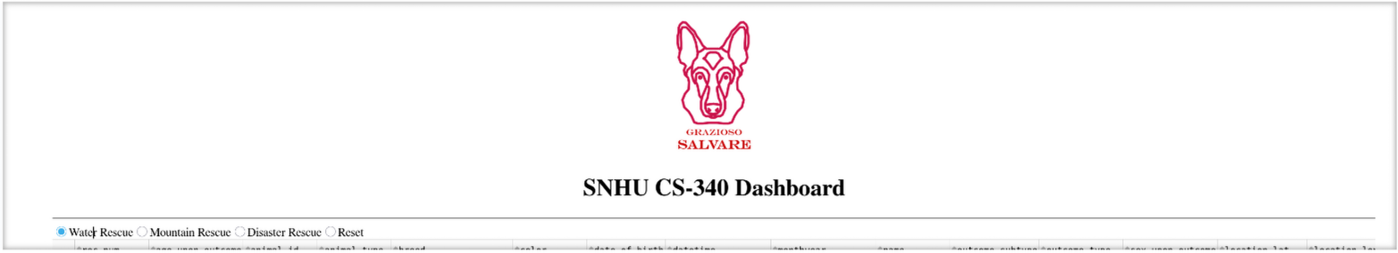
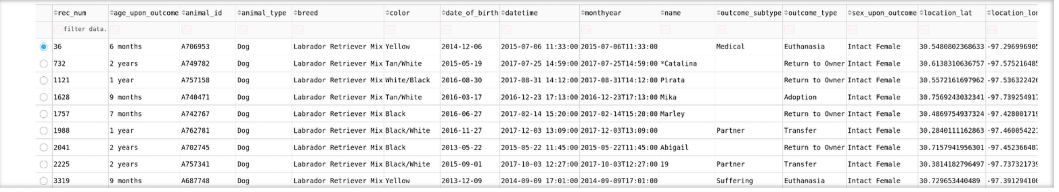
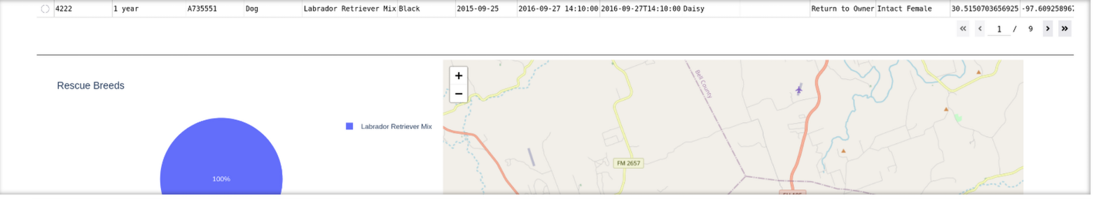

Contact
Your name: Adrian Azevedo

